

Football Should be Fun!
RAMSBURY FOOTBALL CLUB NEWSLETTER
JANUARY 2022
Established 1887
Dear Parents, Guardians and all involved with Ramsbury Football Club,
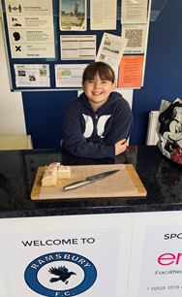
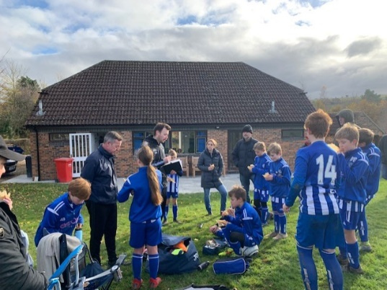
The Ramsbury FC Committee hope you all had a very happy festive break and that you all remain safe and well throughout 2022.
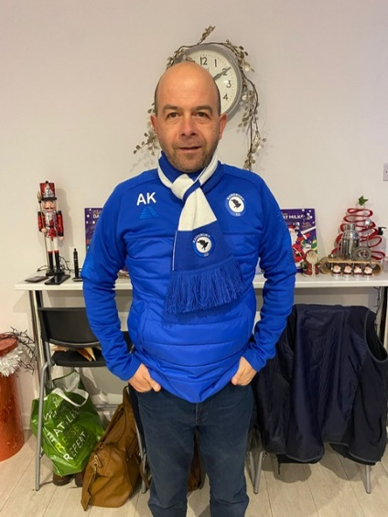
I am sure you will have noticed the ongoing changes to our Clubhouse, courtesy of our fantastic sponsors Ergo Facilities Management, and especially the upgraded and very clean toilets and showers, superb new patio and the table football in the Clubhouse Cafe. We now have a fully functioning kitchen and a much nicer area to sit, relax and enjoy a cup of tea or coffee and a snack while the kids train or play their matches. The Clubhouse refurbishment has been long over-due and we are so grateful to Arthur and Karen Carrington and the whole team at Ergo FM for doing such a brilliant job and, also, to those on the committee that have helped with planning and making our facilities so good. It has been a great community project and we are without doubt the envy of many bigger clubs!
However, our wonderful Football Club is only as good as it is because of the support it gets from the boys and girls who play in our 10 youth teams; the 25 plus in our senior squad and the small band of committed volunteers who help train and coach the teams and manage the Club’s affairs. Without our volunteers we would not have the admiration and respect of other bigger clubs, the League and the FA who praise our facilities, our player’s behaviour and club ethos and, of course, the warm welcome visiting teams receive when they play at the Ramsbury Recreation Ground. You have all been fantastic.
So, thank you to all those involved with Ramsbury FC and let us keep up the momentum in 2022.
Andy Knowles: Club Chair and U17s Coach

RAMSBURY FC WIN ANOTHER WILTSHIRE FA AWARD
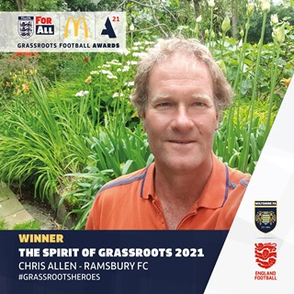
Ramsbury FC were once again recognised in the Wiltshire FA #GrassRootsHeroes awards with Chris Allen winning the Spirit of Grassroots 2021 award for his outstanding work as a youth coach and club treasurer.
Chris has now left the club as his family have relocated to Cornwall, but he left a fantastic legacy and was instrumental in setting up our current Under 7 and Under 8 teams and also helping recruit both coaches for the U9 teams.
For his outstanding work he was also awarded the inaugural Ramsbury FC ‘Rushen Shield’ as the Ramsbury FC Coach of the Year and he remains a great ambassador for the Club.
It is another fantastic award for both Chris and Ramsbury FC and we are delighted with the award to Chris as it is well deserved.
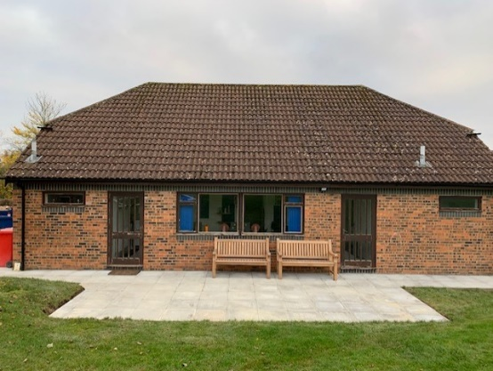
CLUBHOUSE REFURBISHMENT CONTINUES WITH A NEW PATIO
Ramsbury FC, in partnership with Ergo FM, our Club Sponsor, and supported by Ian Smith and the Recreation Ground Committee, completed the refurbishment of the Clubhouse with the installation of a brand new patio and walkway. It makes such a difference compared to the uneven and broken paving slabs that had been an eye sore and hazard for so long.
Not only do we have a fantastic new patio, but Ergo FM also installed a brand new electronic keypad entry system replacing the old simplex lock that had been in place for decades and was well overdue upgrading.
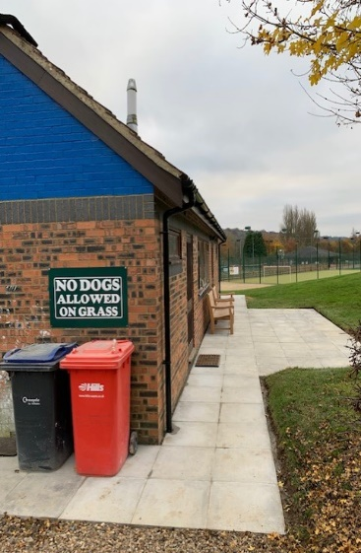
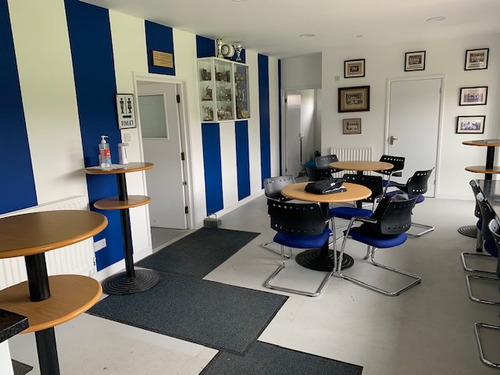
The refurbishment is now near completion with only cosmetic work to be completed to some windows and doors. It is a great achievement and a superb facility to have as a grass roots community football club.
Let’s make sure it is well used and ensure you visit the Clubhouse Café on Saturday and Sunday mornings!
End of the Year Curry and Beers in the Royal British Legion
DO YOU KNOW YOUR TEAM COACHES OR CLUB OFFICIALS?
Under 6s Team Coaches: Al Collis & Ned Llewellyn, Fi Cresswell (Administration)
Under 7s Team Coaches: James Underwood (Level 2 Coach), Ian & Fi Cresswell (FA Playmaker), Matt Thomas
Under 8s Team Coaches: Steve Taylor (FA Playmaker), Pete Wheeler, Fi Cresswell (FA Playmaker)
Under 9s Team Coaches:
U9 (White): Bash Miah (FA Playmaker), Franco Capoferri, Dougal Watts, Phil Oram (Parent Helpers), Kate Abbott (Administration)
U9 (Blue): Nicky Place (FA Playmaker), Rob Green (FA Playmaker), Rupert Harrison (FA Playmaker), Al Wade and Ian Mundy (Parent Helpers)
Under 10s Team Coaches: Dan Beck (Level 1), Matt Crame (FA Playmaker)
Under 11s Team Coaches: Olly Scott Harden (FA Playmaker), Si Bartholomew (FA Playmaker), Ben Jackson (Parent Helper)
Under 12s Team Coaches: Rich Gillard (Level 1 Coach), Adam Blanchford (FA Playmaker), Adrian Fisher (Parent Helper)
Under 13s Coaches: Rob James (Level 1 Coach), James Collister.
Under 16s Coaches: Mark Savory (Level 1 Coach), Rich Englefield (Level 1 Coach), Nigel Hawkins (FA Playmaker), Harrison Yates (FA Playmaker & GK Coach)
Under 17s Coaches: Geoff Pratt (Level 1 Coach & GK Coach), Andy Knowles (FA Playmaker & Club Chair)
Senior Team Coaches: Sean Eviil and Chris Roberts (Level 1 Coach, Club Vice Chair & Club Welfare Officer (CWO))
Club Treasurer: Bryony Beck Club Secretary & Club Welfare Officer: Jon Symon

Ramsbury FC Coaches and Committee members enjoyed a great night out in the Ramsbury Royal British Legion (RBL). The function was to thank them for their commitment and fantastic efforts throughout the year.
The curry was provided by Ruchi Indian Restaurant in Old Town Swindon and delivered by Bash Miah, the U9 (White) Coach, as it is his family’s restaurant. The food was amazing and suited all tastes from mild to cheekily hot and was suitably washed down with plenty of beers.
A huge thanks to the RBL who hosted the event brilliantly and showed us all what a great community club it is. Go and use it!
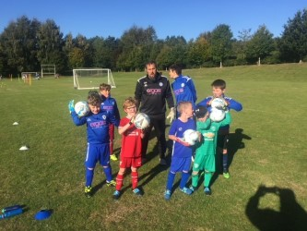
Goalkeeping Training with U17s Coach Geoff Pratt
We are fortunate as a grass roots football club to have two qualified Goalkeeping Coaches: Harrison Yates who is Assistant Coach with the U16s and Geoff Pratt who along with Andy Knowles coaches the U17s.
Harrison as a young coach has concentrated on successfully completing his FA Playmaker qualification and helping with the U16s and Geoff although fully engaged with the U17s has managed to find time to provide our budding keepers in the younger age group teams with some valuable coaching tips and techniques.
All sessions were a huge hit and Geoff plans to hold more training in 2022 in between managing and training the U17s. Well done Geoff and we will announce the next sessions once known.
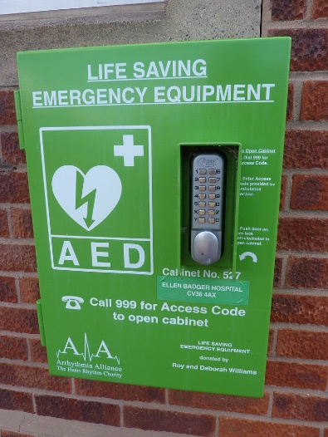
A New Automated Emergency Defibrillator (AED) for Ramsbury FC
Our Club Vice Chair and Senior team Captain Chris Roberts successfully secured an Automated Emergency Defibrillator (AED) for Ramsbury FC. This is brilliant news and the AED will be set up soon.
The AED is an amazing addition to AEDs already located in Mill Lane and at the Tennis Club. Although most of our coaches are fully trained in First Aid and in the use of an AED, it is a really simple and easy device to use and can be a life saver if faced with Sudden Cardiac Arrest (SCA).
This link provides a useful guide of how to use an AED:
Automated External Defibrillators - Red Heart Association
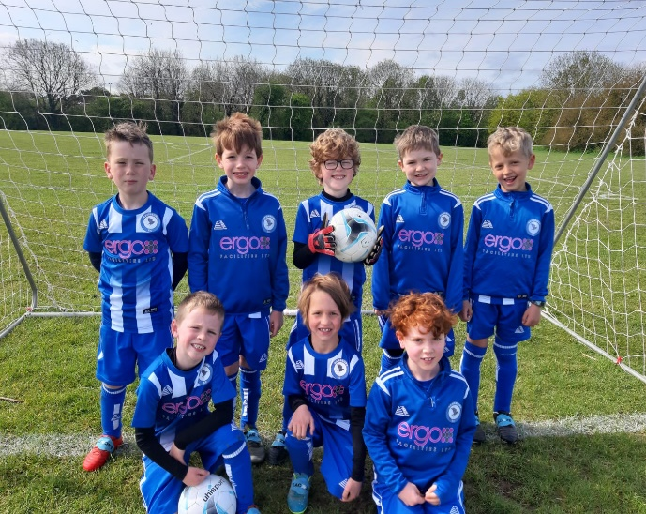
Ramsbury FC Shop via the Ramsbury FC Web Site
All our teams look fabulous in their distinctive Ramsbury FC / Ergo FM branded strips, tracksuit tops and hoodies. There is so much more now on offer in our online shop so go ad have a browse.
The Ramsbury FC online shop is accessed via the Ramsbury FC web site or via our partners Pendle Sportswear and we have been delighted with the collaboration so far and the quality of kit provided.
Look out for our new Ramsbury FC branded items and especially the high quality jackets for winter!

Products for Ramsbury FC (pendlesportswear.co.uk)
Ramsbury FC Ethos
WE NEED YOU TO SUPPORT YOUR FOOTBALL CLUB
YOUR CLUBHOUSE NEEDS YOU! Volunteers are needed to help in the Clubhouse Café on Saturday and Sunday mornings and if you or your friends or family are able to help then please pop into see Jon or contact him at jonthansymon@hotmail.com or contact us through the Club web site at www.RamsburyFC.co.uk
WE NEED YOU AS A COACH! Each youth team MUST have a qualified coach to be able to play in the FA sponsored Leagues and without one we just cannot enter our teams. Currently, most teams have a coach, which is great, but we will need a coach or coaches for the U7s team next season (who will move up from the U6s) in order for them to play in the league. Without dedicated coaches we cannot field a team and can only deliver training. Parents or guardians who want to qualify as coach require to complete DBS, with the cost covered by the Club, and complete the FA Playmaker Course, which is free and online – If you are interested then please contact Jon Symon: jonathansymon@hotmail.com It would be great to have you as one of our Coaches!
Our football club ethos is contained in our Club Ethos and Code of Conduct policy that can be accessed via the policies section of our club web site. Downloads | Ramsbury Football Club (ramsburyfc.co.uk) Our Ethos is a written declaration that sets out how we as a club want the club to be run. It is simple and concise and should be easily understood by players, parents and officials alike:
• We aspire to provide football to children of all ages and abilities, in a safe, friendly and fun environment.
• We will deliver age-appropriate coaching to support long-term player development.
• We want to encourage all players to try their best and make the most of their abilities.
• Provide a supportive approach in all that we do and an environment where children can learn from their mistakes without undue pressure and anxiety.
• Promote good behaviour and have respect for others.
• Encourage a coaching philosophy that provides clear direction, honesty, purpose and appropriate guidance to the process of coaching young players.
• Communicate effectively, clearly and sympathetically, within and without the Club, to promote an enjoyable and fully inclusive environment.
We aim to promote a holistic approach to all that we do based upon the FA’s four-corner model for long-term player development and with age-appropriate coaching for all teams. An essential element of the Club ethos is that all involved with the Club accept, endorse and comply with the Club’s Ethos and Code of Conduct.
Jon Symon, Ramsbury FC Secretary and Club Welfare Officer

